|  |
| --- |
| HRM Use-case Description |
| Manage Training Information |
| [Type the abstract of the document here. The abstract is typically a short summary of the contents of the document. Type the abstract of the document here. The abstract is typically a short summary of the contents of the document.] |

6/5/2012

Table of Contents

1 Use Case Description 1

1.1 Brief Description 1

1.2 Actors and UC Associations 2

2 Pre-conditions 2

3 Post-conditions 2

4 Flow of Events 2

4.1 Basic flow – View information 2

4.1.1 The flow starts: 2

4.2 Alternative Flow 1 – Add new information 3

4.3 Alternative Flow 2 – Edit information 3

The flow starts: 3

4.4 Alternative Flow 3 – Delete information 3

The flow starts: 3

4.5 Alternative Flow 4 – Print data 4

The flow starts: 4

5 Exception Flow 4

5.1 Exception Flow 1 – Add, Edit information 4

5.2 Exception Flow 2– Disconnection database 4

6 Activities Diagram 5

7 Business Rules 6

8 Special Requirements 6

# Use Case Description

## Brief Description

This use case allows user to Manage Training Information. And this use-case include Manage Training, Manage Internal Training, Manage Training Result (3 child use-cases have function with Manage Training Information and they place at tab in system which user can choose them in Manage Training Information).

The following flows are described in this document:

* View information
  + Search information
  + Sort information
  + Filter information
* Add new information
* Edit information
* Delete information
* Print data

## Actors and UC Associations

**Actors:**

* Human Resource Planning and Managing Department members

**Use Case Associations:** depend on Manage Detail Information (If Manage Detail Information doesn’t have info => don’t use function in this use-case)

# Pre-conditions

1. User must log into HRM system
2. User has access Manage Training Information tab.

# Post-conditions

The information is viewed or updated.

# Flow of Events

## Basic flow – View information

### 4.1.1 The flow starts:

1. User is in a personal information management page and chooses menu “Training management”.
2. The system displays a page as described in GUI – Manage Training Information Management, with all personal information had been stored in HRM system before.

The flow ends.

4.1.2 Search information

1. User inputs object that needs to search in a text field

2. User chooses “Search” button

3. The system handles and displays the information that user needs

The flow ends.

4.1.3 Sort information

1. User chooses object in a list to sort

2. The system handles and displays the information that user needs

The flow ends.

4.1.4 Filter information

1. User chooses object in a list to filter

2. The system handle and displays the information that user needs.

The flow ends.

## Alternative Flow 1 – Add new information

The flow starts:

1. User chooses menu “Manage Training Information”.
2. The system displays a tab as described in GUI – Manage Training Information.
3. Click button “add”
4. User input data
5. User can choose “OK” button or “Cancel” button.

* If user choose “OK” button, data will be saved.
* If user choose “Cancel” button, data won’t be saved.

The flow ends.

## Alternative Flow 2 – Edit information

### The flow starts:

1. User chooses menu “Manage Training Information”.
2. The system displays a tab as described in GUI – Manage Training Information.
3. Choose information need edit
4. Click button “edit”
5. User can choose “OK” button or “Cancel” button.

* If user choose “OK” button, data will be saved.
* If user choose “Cancel” button, data won’t be saved.

1. The flow ends.

## Alternative Flow 3 – Delete information

### The flow starts:

1. User chooses menu “Manage Training Information”.
2. The system displays a tab as described in GUI – Manage Training Information.
3. Choose information need delete
4. Choose delete this information
5. User can choose “OK” button or “Cancel” button.

* If user choose “OK” button, data will be saved.
* If user choose “Cancel” button, data won’t be saved.

1. The flow ends.

## Alternative Flow 4 – Print data

### The flow starts:

1. User chooses menu “Manage Training Information”.
2. The system displays a tab as described in GUI – Manage Training Information.
3. Choose “print” button

The flow ends.

# Exception Flow

## Exception Flow 1 – Add, Edit information

1. At step 3 of Alternative flows, the user chooses “Cancel” button
2. The system displays a message “Do you really close it”
3. The actor acknowledges message
4. The system closes the message, doesn’t save data and back to personal management page

The flow ends

## Exception Flow 2– Disconnection database

1. At step 3 of Alternative flows, HRM system disconnects database
2. The system displays a message “HRM disconnect”
3. The actor acknowledges message
4. The system closes the message, back to log in page.

The flow ends

# Activities Diagram

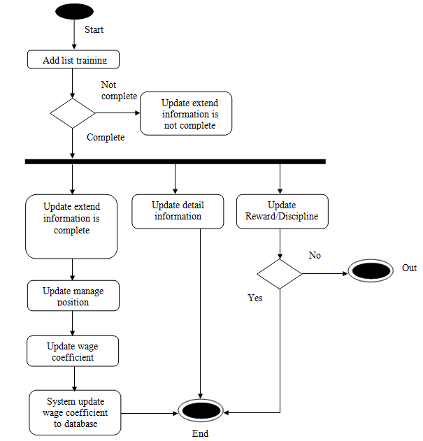

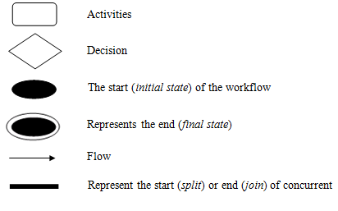

# Business Rules

# Special Requirements

Use case can satisfy security and performance.